Pizza Sales Analysis

--Total Revenue

SELECT FORMAT (SUM(total_price), 'N2') as Total_Revenue from pizza_sales;

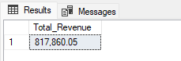

-- Averge Order Value

SELECT ROUND (SUM(total_price) / COUNT(DISTINCT CAST(order_id AS VARCHAR)), 2) AS Average_order_value

FROM pizza_sales;

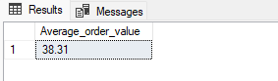

--Total Pizza sold

SELECT FORMAT (SUM(quantity), 'N0') AS Total_quantity_Sold from pizza_sales;

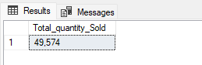

--Total Orders

SELECT FORMAT(COUNT(DISTINCT order_id),'N0') AS Total_Orders FROM pizza_sales;

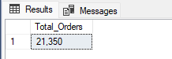

--Average Pizzas Per Order

SELECT CAST

(CAST (SUM(quantity) AS DECIMAL (10,2)) /

CAST(COUNT(DISTINCT order_id) AS DECIMAL(10,2)) AS DECIMAL (10,2))

AS Average_pizza_per_order FROM pizza_sales;

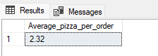

--Daily Trend for Total Orders

SELECT DATENAME(DW, order_date) AS Days, FORMAT (COUNT(DISTINCT order_id), 'N0') AS Total_Orders

FROM pizza_sales GROUP BY DATENAME(DW, order_date);

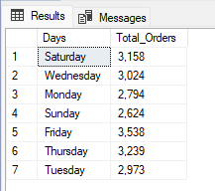

--Hourly Trend for Total Orders

SELECT DATEPART(HOUR, order_time) AS Hours, FORMAT (COUNT(DISTINCT order_id), 'N0') AS Total_Orders

FROM pizza_sales GROUP BY DATEPART(HOUR, order_time) ORDER BY COUNT(DISTINCT order_id) DESC;

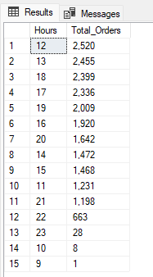

--Percentage of sales by Pizza Category

SELECT pizza_category AS Pizza_Category, FORMAT (SUM(total_price), 'N2') as Total_Revenue,

ROUND (SUM (total_price) * 100 / (SELECT SUM (total_price) FROM pizza_sales),2) AS Percentages

FROM pizza_sales GROUP BY Pizza_Category ORDER BY SUM(total_price) DESC;

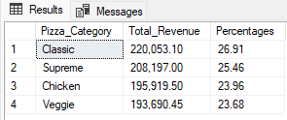

--Percentage of sales by Pizza Size

SELECT pizza_size AS Pizza_Size, CONCAT ('$', FORMAT (SUM(total_price), 'N2')) as Total_Revenue,

CONCAT (ROUND (SUM (total_price) * 100 / (SELECT SUM (total_price) FROM pizza_sales),2), '%') AS Percentages

FROM pizza_sales GROUP BY Pizza_Size ORDER BY SUM(total_price) DESC;

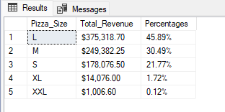

--Total Pizzas Sold by Pizza Category

SELECT pizza_category AS Pizza_Category, FORMAT (SUM(quantity), 'N0') AS Total_quantity_Sold

FROM pizza_sales GROUP BY pizza_category ORDER BY SUM(quantity) DESC;

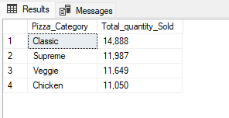

--Top 5 best sellers by Total Pizzas Sold

SELECT Top 5 pizza_name AS Pizza_name, FORMAT (SUM(quantity), 'N0') AS Total_quantity_Sold

FROM pizza_sales GROUP BY pizza_name ORDER BY SUM(quantity) DESC;

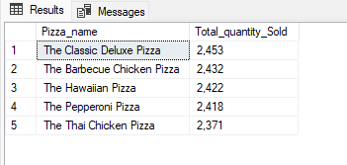

--Bottom 5 best sellers by Total Pizzas Sold

SELECT Top 5 pizza_name AS Pizza_name, FORMAT (SUM(quantity), 'N0') AS Total_quantity_Sold

FROM pizza_sales GROUP BY pizza_name ORDER BY SUM(quantity);

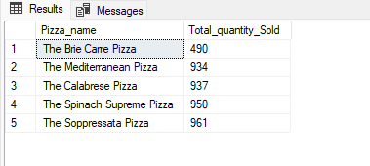

--Pizza name by Total Pizzas Sold

SELECT pizza_name AS Pizza_name, FORMAT (SUM(quantity), 'N0') AS Total_quantity_Sold

FROM pizza_sales GROUP BY pizza_name ORDER BY SUM(quantity) DESC;

SELECT * FROM pizza_sales;